EE3060 Probability – Proposed questions and answers

Question 1:

A biologist wants to estimate l, the life expectancy of a certain type of insect. To do so, h e takes a sample of size n and measures the lifetime from birth to death of each insect. Then he finds the average of these numbers. If he believes that the lifetimes of these insects are independent random variables with variance 1.5 days, how large a sample should he choose to be 98% sure that his average is accurate with+-0.2(+-4.8hours)?

Answer 1:

For i=1,2,….,n, let Xi be the lifetime of the ith insect of the sample.We want to determine n, so that P(-0.2<((X1+X2+….+Xn)/n)-l<0.2)≒0.98

Since E(Xi)=l and Var(Xi)=1.5,by the central limit theorem,

P(-0.2<(($\sum_{i=1}^{n}{Xi}$)/n)-l<0.2)=((-0.2)n< $\sum_{i=1}^{n}{Xi-nl}$ <(0.2)n)=P( $\frac{-\left(0.2\right)n}{√1.5n}$ < $\frac{\sum_{i=1}^{n}{Xi-nl}}{√1.5n}$ < $\frac{\left(0.2\right)n}{√1.5n}$)

≒Ф[$\frac{\left(0.2\right)n}{√1.5n}$]- Ф[$\frac{\left(-0.2\right)n}{√1.5n}$]=2Ф[$\frac{0.2√n}{√1.5}$]-1.

Thus the quantity 2Ф[$\frac{0.2√n}{√1.5}$]-1 should approximately equal 0.98; that isФ[$\frac{0.2√n}{√1.5}$] ≒0.99. $\frac{0.2√n}{√1.5}$ =2.33.This gives n=203.58.Therefore, the biologist should choose a sample of size 204.

Question 2:

The lifetime of a TV tube (in years) is an exponential random variable with mean 10. What is the probability that the average lifetime of a random sample of 36 TV tubes is at least 10.5?

Answer 2:

The parameter of the exponential density function of the lifetime of a tube is λ = 1/10. For 1 ≤ i ≤ 36, let Xi be the lifetime of the ith TV tube in the sample. Clearly, for 1 ≤ i ≤ 36, E(Xi) = 1/λ = 10 and σXi = 1/λ = 10. By the version of the central limit theorem , the desired probability is approximately

P ( $\overline{X}$ ≥ 10.5) = P $(\frac{\overline{X}-10}{10/\sqrt{36}}≥\frac{10.5-10}{10/\sqrt{36}})$ = $P(\frac{\overline{X}-10}{\frac{10}{\sqrt{36}}}≥0.30)$ $≈1-∅(0.30)$ = 1 − 0.6179 = 0.3821.

Question 3:

Suppose the age a student graduates from Salem State is Normally distributed. If the mean age is 23.1 years and the standard deviation is 3.1 years, what is the probability that 6 randomly selected students had a mean age at graduation that was greater than 27?

Answer 3:

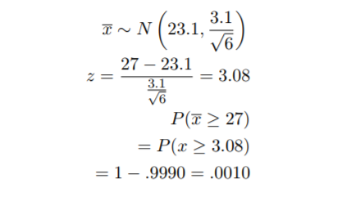

Question 4:

Let Xi, i=1,2,3…… be independent random variables all distributed according to the PDF fx(x) = x/8 for 0<=x<=4. Let S = 1/100Σ100i=1 Xi. Then, what’s the value of P(S>3)?

Answer 4:

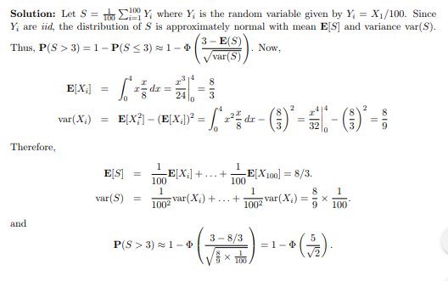

Question 5:

Suppose that you have a sample of 100 values from a population with mean µ = 500 and with standard deviation σ = 80.

a. What is the probability that the sample mean will be in the interval (490, 510)?

b. Give an interval that covers the middle 95% of the distribution of the sample mean.

Answer 5:

